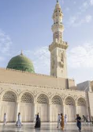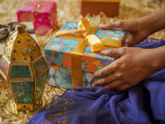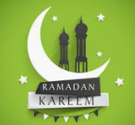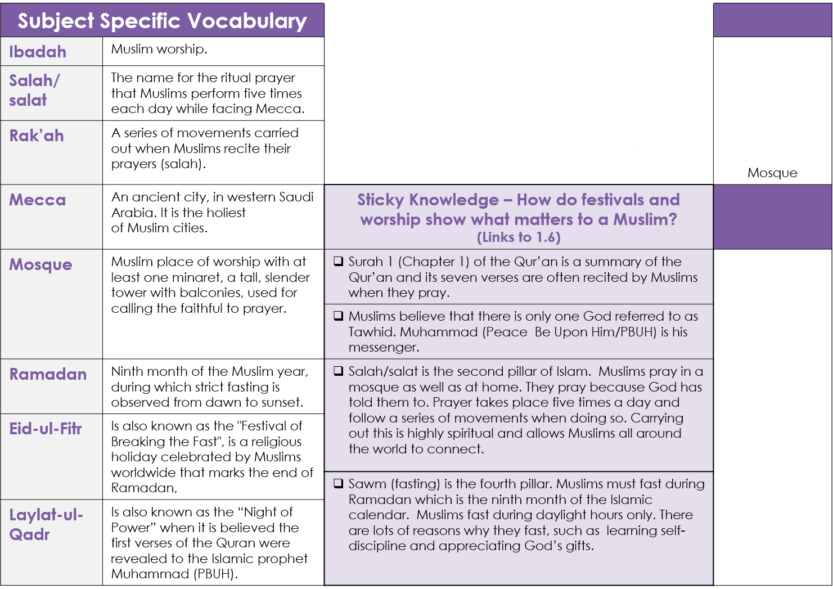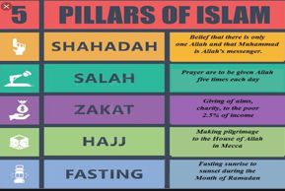

* **Being a Muslim: Knowledge Organiser (Y3)**

GREAT MOOR JUNIOR SCHOOL  
**“Learning Together”**

***Respect, Kindness, Tolerance,   
Responsibility, Co-operation***

**Sticky Knowledge**

Muslims celebrating Eid-ul-Fitr