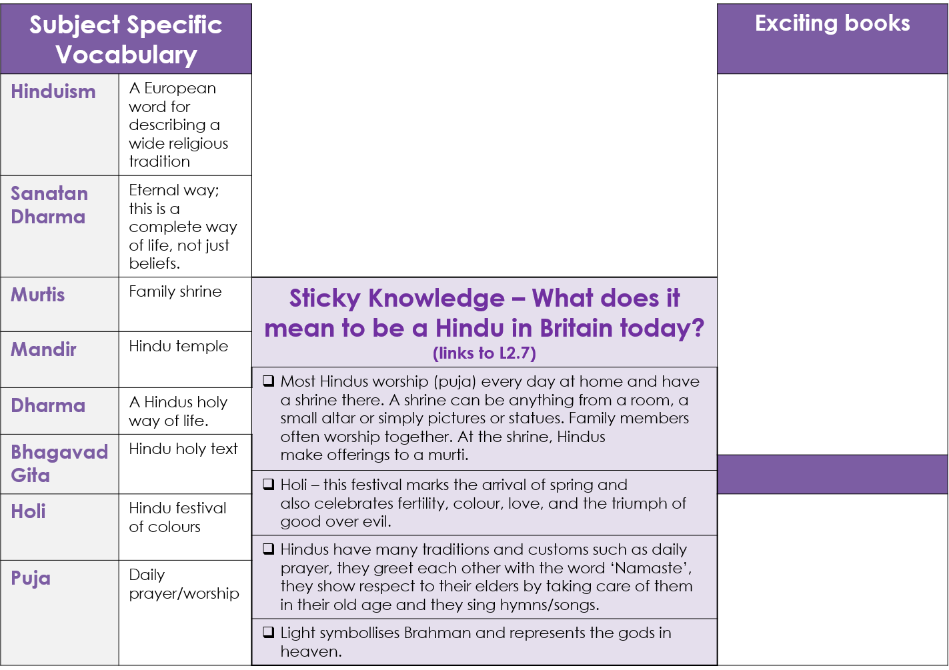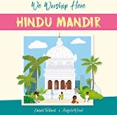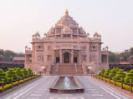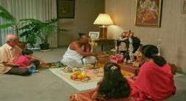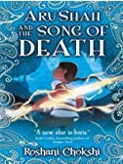

**Hinduism: Knowledge Organiser (Y4)**

GREAT MOOR JUNIOR SCHOOL  
**“Learning Together”**

***Respect, Kindness, Tolerance,   
Responsibility, Co-operation***

Hindus celebrating puja at home

A Mandir

Hindus celebrating Holi



**Sticky Knowledge**

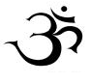

Aum

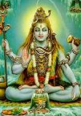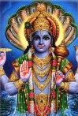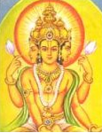

Brahma Vishnu Shiva