**Measurement conversions**

|  |  |  |  |  |  |  |  |  |  |  |  |  |  |  |  |  |  |  |  |  |  |  |  |  |  |  |  |  |  |  |  |  |  |  |  |  |  |  |  |  |  |  |  |  |  |  |  |  |  |  |  |  |  |  |  |
| --- | --- | --- | --- | --- | --- | --- | --- | --- | --- | --- | --- | --- | --- | --- | --- | --- | --- | --- | --- | --- | --- | --- | --- | --- | --- | --- | --- | --- | --- | --- | --- | --- | --- | --- | --- | --- | --- | --- | --- | --- | --- | --- | --- | --- | --- | --- | --- | --- | --- | --- | --- | --- | --- | --- | --- |
| |  |  | | --- | --- | | **Month** | **Days** | | January | 31 | | February | 28 (29 in leap year) | | March | 31 | | April | 30 | | May | 31 | | June | 30 | | July | 31 | | August | 31 | | September | 30 | | October | 31 | | November | 30 | | December | 31 | | |  |  | | --- | --- | | 1 **cent**imetre | 10mm | | 1 metre | 100cm | | 1 **kilo**metre | 1,000 m | | 1 **kilo**gram | 1,000 grams | | 1 litre | 1,000 **milli**litres | |  |  | | 1 minute | 60 seconds | | 1 hour | 60 minutes | | 1 day | 24 hours | | 1 week | 7 days | | 1 year | 365 days (366 in a leap year)  52 weeks | |  |  | | £1 | 100p | | £5 | 500p | |

**Multiplication and division vocabulary**

|  |  |  |
| --- | --- | --- |
| **Term** | **Definition** | **Example** |
| factor | a number that divides exactly into another number | factors of 12 = 1, 2, 3, 4, 6, 12 |
| Factor pairs | a **pair** of numbers that, when multiplied will result in a given product | Factor pairs of 30 =  5and 6  2 and 15  10 and 3  1 and 30 |

**Roman numerals**

|  |  |  |  |
| --- | --- | --- | --- |
| 1 | I | 50 | L |
| 5 | V | 100 | C |
| 10 | X |  |  |

**Year 4 Knowledge organiser**

**AREA**

is the amount of space inside a 2D shape usually measured in squares

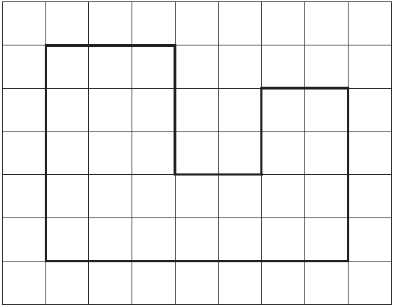Area = 27 squares

**Position and Direction**

**Translation-** *Moving a figure to a new location with no other changes.*

***Symmetry***-  an object is symmetrical when one half  
is a mirror image of the other half.

**Lines of symmetry -** The "Line of Symmetry" (shown here in white) is the imaginary line where you could fold the image and have both halves match exactly.

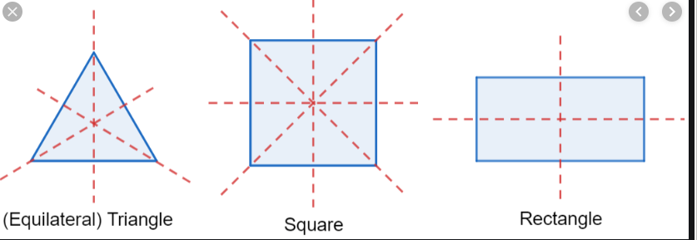

**PERIMETER**

Is the distance around a two-dimensional shape.

Perimeter = 66cm 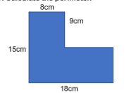

**2D shapes**

|  |  |
| --- | --- |
| **Name** | **No. of sides** |
| quadrilateral | 4 |
| pentagon | 5 |
| hexagon | 6 |
| heptagon | 7 |
| octagon | 8 |
| nonagon | 9 |
| decagon | 10 |

polygon = shape with straight sides regular = all sides/angles the same irregular = sides/angles **not** same

**Types of triangle**



scalene equilateral isosceles

**Types of quadrilateral**



parallelogram trapezium rhombus

**Angles**

|  |  |  |
| --- | --- | --- |
| full turn | 360° |  |
| half turn | 180° | |
| right angle | 90° | |
| acute angle | < 90° | |
| obtuse angle | > 90° | |
| angles on a straight line | 180° | |
| angles inside a triangle | 180° | |
| angles inside a quadrilateral | 360° | |

**Co-ordinates**

Read co-ordinates along the x axis

(horizontal) first, then the y axis

(vertical). E.g. (3,-4) = go right 3, down 4.

**Fractions, decimals & percentages**

|  |  |  |
| --- | --- | --- |
| 1/100 | 0.01 | ÷ 100 |
| 1/10 | 0.1 | ÷ 10 |
| ¼ | 0.25 | ÷ 4 |
| ½ | 0.5 | ÷ 2 |
| ¾ | 0.75 | ÷ 4, x3 |
| 1 | 1 | ÷ 1 |

**Times tables**

**To know multiplication and division facts for multiplication tables up to 12 × 12**

**Time**

To read time on analogue clock.

To know that the shorter (hour) hand points to the hours.

The longer (minute) hand points to the minutes.

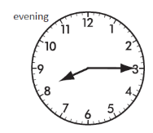

The hour hand has passed 8 and the minute hand is at 15. The time is 8:15 pm.

To know that the 24 hour clock has 4 digits and represents the 24 hours in a day. The first two digits represent the hours that have passed and the last two digits represent the minutes.

**15:23** means that 15 hours and 23 minutes of the day has passed – 15 hours is 3 hours after midday (12pm). Therefore the time is: **3:23 pm.**