**Year 3 Knowledge Organiser**

**PERIMETER**

Is the distance around a two-dimensional shape. 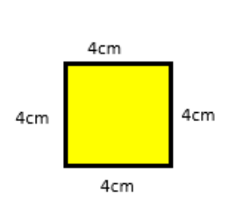Perimeter = 16cm

**2D shapes**

**2D shapes have 2 dimensions- width and height**

|  |  |
| --- | --- |
| **Name** | **No. of sides** |
| triangle | 3 |
| quadrilateral | 4 |
| pentagon | 5 |
| hexagon | 6 |
| heptagon | 7 |
| octagon | 8 |
| nonagon | 9 |
| decagon | 10 |

polygon = shape with straight sides

regular = all sides/angles the same

irregular = sides/angles **not** same

**3D shapes**

**3D shapes have 3 dimensions – width height and depth**

**Vertices are corners**

**Edges**

**faces**

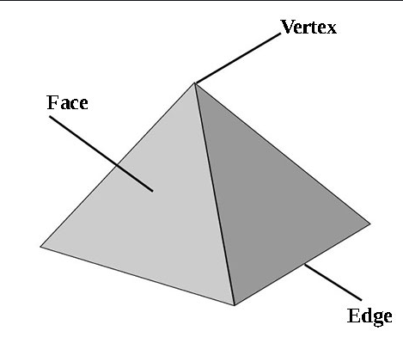

**Roman numerals**

|  |  |
| --- | --- |
| 1 | I |
| 5 | V |
| 10 | X |

**Measurement conversions**

|  |  |  |  |  |  |  |  |  |  |  |  |  |  |  |  |  |  |  |  |  |  |  |  |  |  |  |  |  |  |  |  |  |  |  |  |  |  |  |  |  |  |  |  |  |  |  |  |  |  |  |  |  |  |  |  |  |  |  |  |
| --- | --- | --- | --- | --- | --- | --- | --- | --- | --- | --- | --- | --- | --- | --- | --- | --- | --- | --- | --- | --- | --- | --- | --- | --- | --- | --- | --- | --- | --- | --- | --- | --- | --- | --- | --- | --- | --- | --- | --- | --- | --- | --- | --- | --- | --- | --- | --- | --- | --- | --- | --- | --- | --- | --- | --- | --- | --- | --- | --- |
| |  |  | | --- | --- | | **Month** | **Days** | | January | 31 | | February | 28 (29 in leap year) | | March | 31 | | April | 30 | | May | 31 | | June | 30 | | July | 31 | | August | 31 | | September | 30 | | October | 31 | | November | 30 | | December | 31 | | |  |  | | --- | --- | | 1 **cent**imetre | 10mm | | 1 metre | 100cm | |  |  | | 1 **kilo**gram | 1,000 grams | |  |  | | 1 litre | 1,000 **milli**litres | |  |  | | 1 minute | 60 seconds | | 1 hour | 60 minutes | | 1 day | 24 hours | | 1 week | 7 days | | 1 year | 365 days (366 in a leap year)  52 weeks | |  |  | | £1 | 100p | | £5 | 500p | |  |  | |

**Time**

To read time on analogue clock.

To know that the shorter (hour) hand points to the hours.

The longer (minute) hand points to the minutes.

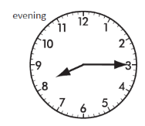 The hour hand has passed 8 and the minute hand is at 15. The time is 8:15 pm.

To know that the 24 hour clock has 4 digits and represents the 24 hours in a day. The first two digits represent the hours that have passed and the last two digits represent the minutes.

**15:23** means that 15 hours and 23 minutes of the day has passed – 15 hours is 3 hours after midday (12pm). Therefore the time is: **3:23 pm.**

**Multiplication and division vocabulary**

|  |  |  |
| --- | --- | --- |
| **Term** | **Definition** | **Example** |
| integer | A number that is not a fraction i.e. a whole number | 1,2,3,4, |

**Fractions, decimals & percentages**

|  |  |  |
| --- | --- | --- |
| 1/10 | 0.1 | ÷ 10 |
| 1 | 1 | ÷ 1 |

**Angles**

To know that angles are a measurement and that they measure a turn. They are measured in degrees.

|  |  |  |
| --- | --- | --- |
| full turn | 360° |  |
| half turn | 180° | |
| right angle | 90° | |

**Shape vocabulary perimeter** = measure around the edge (**circumference** = perimeter of a circle)

Horizontal line parallel lines

Vertical line Perpendicular lines

**Times tables**

**To know multiplication and division facts for multiplication tables 3,4 and 8**