|  |  |  |
| --- | --- | --- |
| English | Focus: Grammar/Punctuation/Spelling | Year 3 |

|  |  |  |  |  |
| --- | --- | --- | --- | --- |
| Spellings I should begin to learn | | | | |
| accident | consider | grammar | notice | regular |
| accidentally | continue | group | occasion | reign |
| actual | decide | guard | occasionally | remember |
| actually | describe | guide | often | sentence |
| address | different | heard | opposite | separate |
| answer | difficult | height | ordinary | special |
| appear | disappear | history | particular | straight |
| arrive | early | imagine | peculiar | strange |
| believe | earth | increase | perhaps | strength |
| bicycle | eight | important | popular | suppose |
| breath | eighth | interest | position | surprise |
| breathe | enough | island | possess | therefore |
| build | exercise | knowledge | possession | though |
| busy | experience | learn | possible | although |
| business | experiment | length | potatoes | thought |
| calendar | extreme | library | pressure | through |
| caught | famous | material | probably | various |
| centre | favourite | medicine | promise | weight |
| century | February | mention | purpose | woman |
| certain | forward | minute | quarter | women |
| circle | forwards | natural | question |  |
| complex | fruit | naughty | recent |  |

|  |  |
| --- | --- |
| **Vocabulary** | |
| Adverb | A word that adds more information about verbs: *Slowly, he turned the key.* |
| Noun | A noun is a naming word. It is **a thing, a person, an animal or a place.** |
| Pronoun | **A pronoun is a word used to replace a noun: he, she, it, they, me, him, her etc** |
| Subordinate clauses | A **subordinate clause** is a clause that cannot make sense on its own:  'I played out until it went dark', |
| Direct speech | Any words spoken by a character in a story – must have inverted commas |
| Preposition | Tells you where or when something is in relation to something else: after, before, on, under, inside, outside *It is on the hill, beside a tree.* |
| Expanded Noun Phrases | *The breath-taking, scenic view spread out in the valley below.* |
| Present Perfect | Use in contrast to the past tense: *I have walked…/You have played…* |

Use a dictionary to check spellings.

|  |  |
| --- | --- |
| Punctuation Reminders: | |
| **A** | Capital letters for sentences, initials and proper nouns |
| **.** | Full stops |
| **?** | Question marks at the end of a question |
| **‘** | Apostrophes for possession: Leo’s or missing letters in contracted words omission: can’t, shouldn’t, I’d |
| **,** | Commas in lists, and to mark parenthesis, after fronted adverbials and clauses to make meaning clear |
| **“ ”** | Inverted commas for speech/dialogue (don’t forget other punctuation too!) |

|  |  |
| --- | --- |
| **Vowel** | a e i o u |
| **Consonant** | b c d f g h j k l m n  p q r s t v w x y z |

|  |
| --- |
| Root Words  **A root word is a basic word with no**[prefix](https://www.theschoolrun.com/what-is-a-prefix)**or**[suffix](https://www.theschoolrun.com/what-is-a-suffix)**added to it: differ – different**, indifferent magic – magician decide - undecided  Suffixes **-ation** *preparation sensation* **-ous** *courageous curious furious* **-ly** *cautiously immediately slowly* |

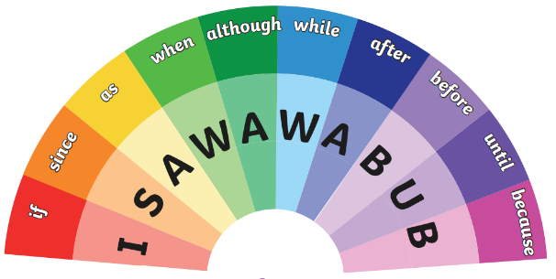

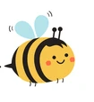

|  |
| --- |
| Begin/link sentences in a variety of ways using conjunctions, adverbs and prepositions  Time:*At that moment…/On Tuesday…/Finally…/Before long…*  Place**:***Around the corner…/Over the bridge…/Behind him…/Next to…*  Manner/Behaviour**:***Breathing heavily…/Without warning…/Gently, he…* |

|  |
| --- |
| Use the subordinating conjunctions in your writing to join sentences. ISAWAWABUB  Also use co-ordinating conjunctions FANBOYS: for/and/nor/but/or/yet/so |

|  |
| --- |
| Begin to join your handwriting Always do your best work – if you do not, you will be asked to do it again |