Great Moor Junior School

Knowledge Organiser

Year 6 2024-2025

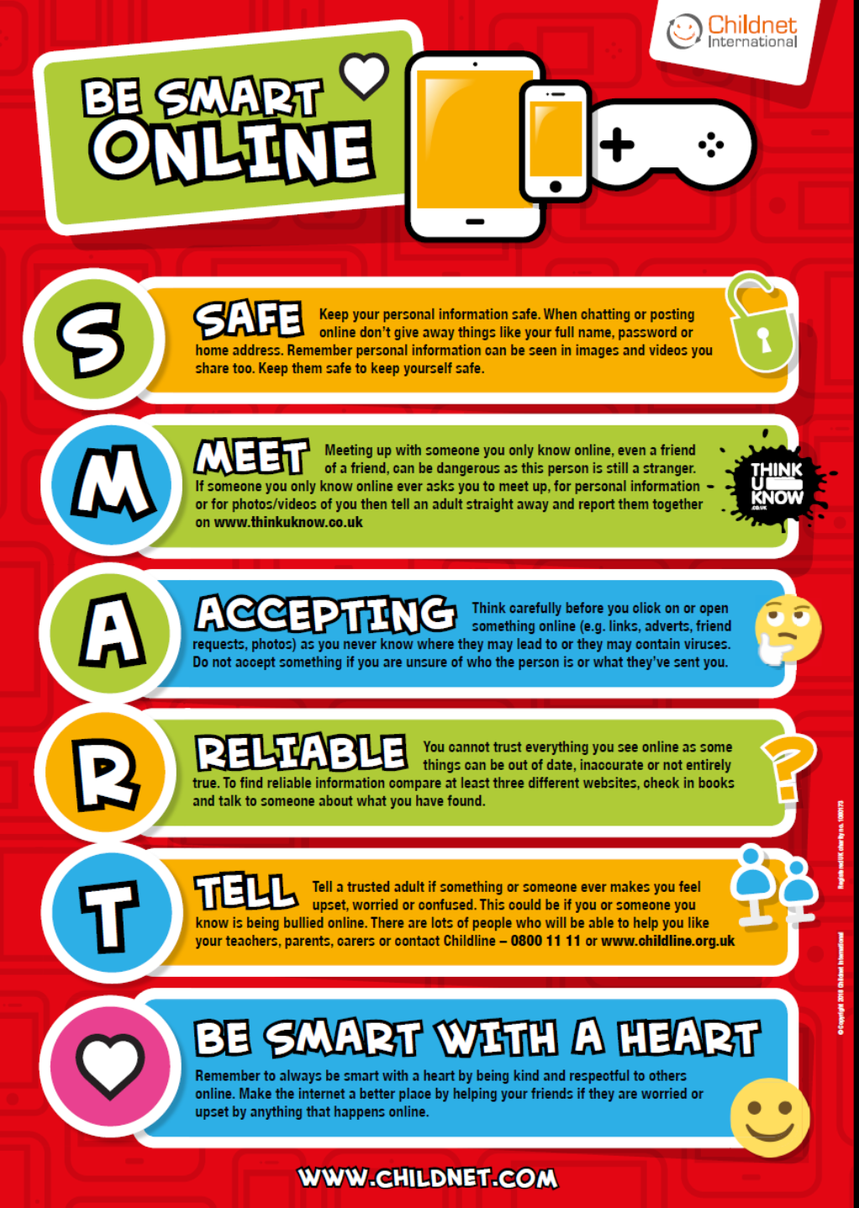

## Year 6 Autumn1 : Websites

|  |
| --- |
| **Computing** Focus: Digital Literacy |

**What they should know from Years 3,4 and 5:** Searching the world wide web, making videos, using presentation software

**In this unit** we will create a web page, adding text, images and hyperlinks; changing the appearance and position of these; and embedding content

**Key Knowledge, vocabulary and skills**

|  |
| --- |
| **HTML** HyperText Markup Language. It marks the content up into different types, sections or structures, like paragraphs, blocks, lists, images, tables, forms, comments etc. It has start and end tags for each of these and some basic ways to present these sections. |
| **CSS** Cascading Style Sheets tell the browser how each type of element should be displayed, which may vary for different media (like screen, print or handheld device). It gives a lot more control and variety over presentation of web pages |
| **Tags** Mark the beginning and end of sections in HTML. e.g., **<p>** the start of a paragraph and, **</p>** the end of a paragraph |
| **Components of a web page**  **Site name**: the name of the whole site  **Headers**: four types of header in Google Sites and it will appear on that page:  **Layouts**: various template layouts in to which you can put text images sound etc  **Footer**: whatever you put there appears on every page of your website |
| **Hyperlinks**: Links one page to another on a web site or to another website’s page or pages |
| **Navigation Path**: By default, the pages you add to your Site will automatically appear in the Navigation bar and show the path from one page to another on your website to enable visitors to navigate from one page to another easily |
| **Embed content** Add content from another website |
| **A home page (or homepage)** is the main web page of a website. |
| **Subpages** Other pages (than the home page) on your web site |

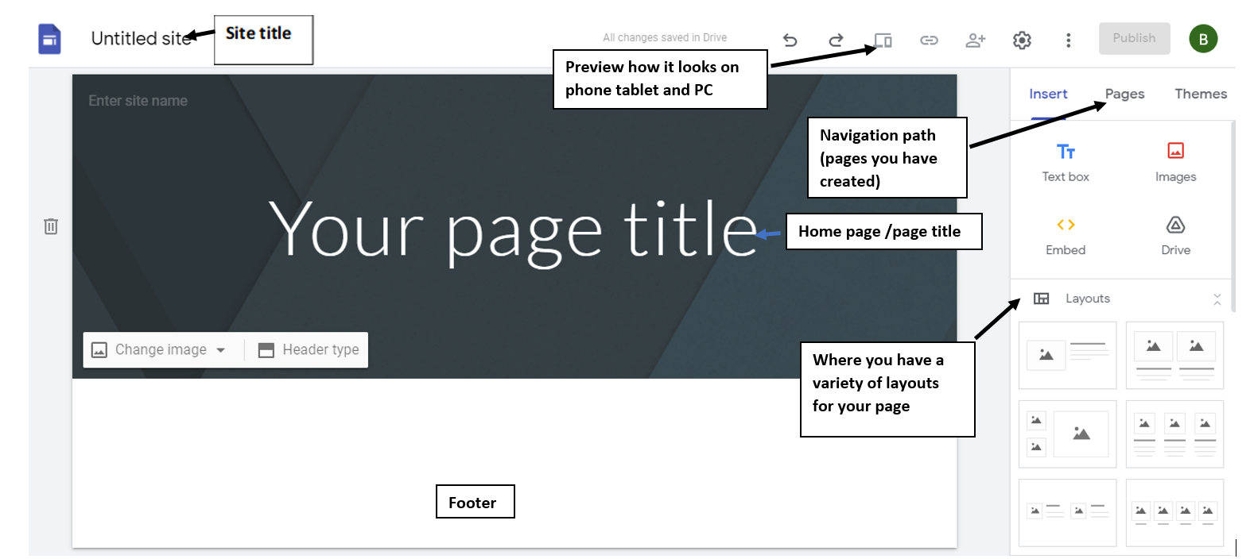

|  |
| --- |
| **Online safety / E-safety**  **Focus on Privacy and security t**o help identify scams and phishing. |
|

## 

## 

## 

## 

## 

## 

## 

## 

## Year 6 Autumn 2: Using spreadsheets to organise data

|  |
| --- |
| **Computing** Focus: Data |

**What they should know from Years 3, 4 and 5:** data, questionnaires, collecting data, presenting data in graphs, bars charts etc.

**In this unit** we learn about using a spreadsheet to create totals and averages and solving a problem. We will use Google Sheets too.

**Key Knowledge, vocabulary and skills**

|  |  |
| --- | --- |
| Excel spreadsheet layout | |
|  | |
| **Data** | It can be letters, words, numbers, dates, images, sounds, etc. It needs a context to turn it into information otherwise it has little meaning to humans e.g., 03.09.20., blue. |
| **Information** | This is data that has been processed so that it refers to something and so people can read, understand, and use it, e.g. date started school 03.09.12. Colour of eyes: blue. |
| **Formula** | A formula is an equation e.g., 4 + 6 = 10 that calculates data in your spreadsheet. They are entered into a cell in your spreadsheet. They begin with an = sign. |
| **Cell** | A cell is a rectangle in the spreadsheet, They each have a name: column letter and row number e.g. B6 |

|  |
| --- |
| **Online safety / E-safety**  **Focus on Online Bullying:** (linked to anti-bullying week) help to report online bullying in different contexts. |
|

## Year 6 Spring 1: Modelling the Internet

|  |
| --- |
| **Computing** Focus: Understanding Technology (Communication and Networks) |

**What they should know from Year 3, 4 and 5:**learnt about Local Networks and devices that link up a local network

**In this unit** we deepen knowledge of the Internet and how it works

**Key Knowledge, vocabulary and skills**

|  |
| --- |
| **Search Engines** Examples are Bing, DuckDuckGo, Google Chrome etc. They all have different algorithms for searching and so come up with different results. Their algorithms will include how **web crawlers** create an **index** and how pages are **ranked**. Some search engines rely on advertisers and this affects the order of results. |
| **An Index** in a non-fiction book allows us to quickly locate something. Indexes for search engines are ordered (e.g. alphabetically), which helps us to find what we’re looking for quickly and efficiently. |
| **Selection** explains which web pages a search engine displays. |
| **Ranking** explains the order in which they are displayed. Points are given depending on where a word is placed. eg. the algorithm might give more weighting (points) if the word searched for is in the title. |
| **Routers** are devices that get information to where it needs to be across the internet |
| **Internet protocol (IP) address**. An IP address is a label which is used to identify devices on a computer network. IP addresses are usually written as a set of numbers in a given order. All we see is the web address beginning www. |
| **Servers** are computers set up locally to provide services to a LAN. Or setup to provide **internet** services, such as the world wide web, e-mail or online games. |
| **Packets** If your computer sends a request to a web server for an image, the request is sent in a ‘packet’. A packet is like a virtual parcel that has lots of information attached to it. The most important information is the IP address of the web server the image is stored on and the IP address of your computer. |
| **Cyber security** deals with online threats e.g. hacking and keeping your data secure |
| Devices you might come across when modelling the internet. |

|  |
| --- |
| **Online safety / E-safety**  **Safer Internet day**. **Focus on online reputation** and describe ways that regulate age-related content (e.g. PEGI, BBFC, parental warnings etc.) |
|

## Year 6 Spring 2: Introducing variables to create Maths games

|  |
| --- |
| **Computing** Focus:Computer Science |

**What they should know from Years** [**3a**](https://docs.google.com/document/d/14dAWr1pAQJeejYA_xUGhwebMG5SPkvzKIur-0YQBrOQ/edit#bookmark=id.g2f384invsr1)**,** [**3b**](https://docs.google.com/document/d/14dAWr1pAQJeejYA_xUGhwebMG5SPkvzKIur-0YQBrOQ/edit#bookmark=id.njak0acfllp8)**,** [**4a**](https://docs.google.com/document/d/18BvyuXmY9VLUaC6v5Kl3hn3N9cngle9WEietXAd7OZI/edit#bookmark=id.kinav5h7t0q8)**,** [**4b**](https://docs.google.com/document/d/18BvyuXmY9VLUaC6v5Kl3hn3N9cngle9WEietXAd7OZI/edit#bookmark=id.vumytvfpxhe) **and** [**5**](https://docs.google.com/document/d/1FDPAydk8FwPgNUz-kKP19ZtxMHj_0AWLdbm_JkPnkzQ/edit#bookmark=id.yc9ttquymq7d) **:**sequence, algorithm, bug, debugging, computer program, executing/running a program, repetition loops and decomposition

**In this unit** we will create a simple Maths game and then one with variables

**Key Knowledge, vocabulary and skills**

|  |  |
| --- | --- |
| **Selection** | See autumn 2 |
| **Event blocks** | These start Scratch to start running a program by setting a triggering moment, e.g. clicking the green flag, pressing the spacebar etc. |
| **repetition:**  **loops** | It is a set of actions or events that are repeated either a number of times or forever. |
| **variable** | A **variable** is a changeable value (it can change as the program runs). Variables only hold one value at a time. These values can be either numbers or [strings](https://en.scratch-wiki.info/wiki/String) — any text.   Variables are found in **variable blocks in Scratch,** which you create.  This enables the computer program to count down the game or score points.  To find dout more  <https://www.bbc.co.uk/bitesize/topics/zkcqn39/articles/zw3dwmn> |
| **strings** | Strings are sequences of letters and numbers |

|  |
| --- |
| **Online safety / E-safety**  **Focus on Self-Image and Identity:** to describe issues online that could make anyone feel sad, worried, uncomfortable or frightened |
|

## 

## Year 6 Summer 1: BBC Micro: bits

|  |
| --- |
| **Computing** Focus: Computer Science |

**What they should know from Years 3, 4 and 5** sequence, algorithm, debugging, repetition (loops), selection, variables, decomposition, MakeCode, and flashing programs

**Links to Micro:bits in Year 5:** we used sequences, repetition, selection and variables utilising - the micro:bit.

**In this unit** we will again use and build further upon sequences, repetition, selection and variables utilising - the micro:bit and Scratch. We will build and test a number of projects linking Scratch to the micro:bit

The links below will be used during lessons:

[How to link your micro:bit to Scratch guide](https://scratch.mit.edu/microbit)

[Microbit/ Scratch join projects link](https://microbit.org/projects/make-it-code-it/?filters=scratch)

**Key Knowledge, vocabulary and skills**

|  |  |
| --- | --- |
| **MakeCode** | Programming language for the BBC micro:bit (similar to Scratch) |
|
|
|
| **flashing programs** | The code that is initially created on a website and then clicking on ‘download’ moves it to the local machine in the form of a **.hex file**. Flashing occurs when the code is copied to the micro:bit (a device you will see on your computer or iPad). |
| **Emulator** | Is used to test your program and see how it will appear |
| **program flow**  **flow chart** | Example of flow chart for shaking the micro:bit using algorithm to the left. |

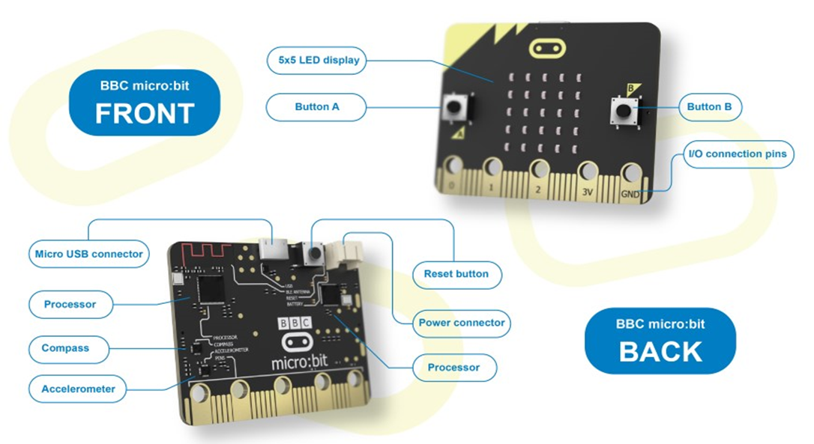

|  |
| --- |
| **Online safety / E-safety**  **Focus on Health Well-being and lifestyle** to explain the ways in which anyone can develop a positive online reputation |
|

## Year 6 Summer 2: Code Cracking

|  |
| --- |
| **Computing** Focus**:** Digital Literacy (IT and E-safety) and Using technology |

**What you should know from Year 3 4 and 5**: using iMovie, creating algorithms, PowerPoints and using effective searching

In this unit we will crack a code. Use effective searching. Learn about Alan Turing. Create a storyboard and plan a presentation.

**Key Knowledge, vocabulary and skills**

|  |  |
| --- | --- |
| **Algorithm** | An algorithm is a sequence of instructions that are followed to complete a task. Computers need the algorithm to be translated into code which the computer will then follow to complete a task. This code is written in a programming language. There are many different types of programming languages e.g. Scratch. For more information:<https://www.bbc.com/bitesize/articles/zqrq7ty> |
| **Debug** | Computer programmers sometimes make mistakes when writing their code. These mistakes are known as “bugs”. An important part of programming is testing your program and 'debugging' (removing the bugs).<https://www.bbc.com/bitesize/articles/ztkx6sg> |
| **Alan Turing** | Alan Turing was a British mathematician. He made major contributions to the fields of mathematics, computer science, and artificial intelligence. He worked for the British government during World War II, when he succeeded in breaking the secret code Germany used to communicate. |
| **Code** | A code is a system of rules to convert information—such as a letter or word - into another form of letters, numbers or numbers, sometimes it is done to make the message secret. |
| **Enigma machine** | Enigma was a device used by the German military command to encode strategic messages before and during World War II. |

|  |
| --- |
| **Online safety / E-safety**  Focus on copyright and ownership. We assess and justify when it is acceptable to use the work of others. And give examples of content that is permitted to be reused and know how this content can be found online. |