Year 5 Expectations:  Writing Composition  Plan  - Think aloud to generate ideas  - Begin to identify the audience and purpose of the writing  - Begin to understand the appropriate form for the audience and purpose of the writing across the curriculum  - Use similar writing as models for own writing  - With support, note and develop initial ideas logically, drawing on reading or research where necessary  - Begin to consider how authors have developed characters/settings in narrative texts that have been read, listened to, or seen performed  Draft and Write  - Select appropriate grammar and rich vocabulary, beginning to understand how such changes can make meaning clearer or can change the meaning  - In narratives, describe settings, characters, and atmosphere  - Include dialogue to express character and advance action  (The speech of a character should cause any action in the story to move forward, or uncover relevant plot information)  - With support, begin to summarise a text, giving key information  - Learn to use a range of devices to build cohesion within and across paragraphs: time conjunctions, subordinating and co-ordinating conjunctions; adverbials; correct tense; developed noun phrases and  varied pronouns (a chain of reference)  - Begin to use a wider range of devices to organise and present texts which help to guide the reader (headings, sub-headings, bullet points and under-lining, numbering, fact boxes, pictures, diagrams and captions) | Evaluate and Edit  - Assess the effectiveness of their own and others’ writing  - Re-read own writing to check that the meaning  is clear  - Suggest changes to vocabulary, grammar and punctuation to enhance effects and make meaning clear  - With support, apply the correct and consistent use of tense  - Ensure correct subject and verb agreement when using singular and plural  - Begin to distinguish between the formal and informal spoken and written forms, using them in the correct context in writing  - Proof-read for spelling and punctuation errors    - Perform own compositions, attempting to use appropriate intonation, volume, and movement so that meaning is clear

Year 5 Expectations for Reading

Word reading

- Apply knowledge of root words, prefixes and suffixes to read aloud and understand the meaning of unfamiliar words
- Use prior knowledge of similar looking words to attempt correct pronunciation of unfamiliar words
- Re-read and read ahead to check for meaning
- Ensure all letters in a word are considered when reading it
- Read fluently, using punctuation to inform meaning

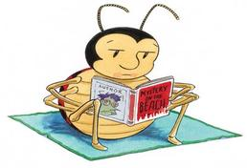
Year 5 Expectations for Spoken Language
Pupils should be taught to

- Listen and respond appropriately to adults and their peers
- Ask relevant questions to extend their understanding and knowledge
- Use relevant strategies to build their vocabulary
- Articulate and justify answers, arguments and opinions
- Give well-structured descriptions, explanations and narratives for different purposes, including for expressing feelings
- Maintain attention and participate actively in collaborative conversations, staying on topic and initiating and responding to comments
- Use spoken language to develop understanding through speculating, hypothesising, imagining and exploring ideas
- speak audibly and fluently with an increasing command of Standard English
- participate in discussions, presentations, performances, role play, improvisations and debates
- Gain, maintain and monitor the interest of the listener(s)
- Consider and evaluate different viewpoints, attending to and building on the contributions of others
- Select and use appropriate registers for effective communication.


Year 5 Expectations for  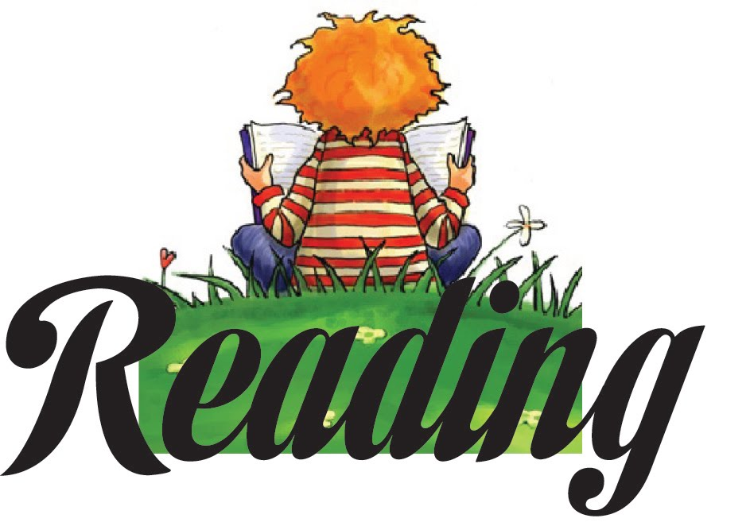  Comprehension  - Continue to read and discuss a range of fiction, poetry, plays, non-fiction and reference or text books  - Read books that are structured in different ways for a range of purposes (Fiction and Non-fiction)  - Increase familiarity with a wide range of books such as myths, legends, traditional stories and books from other cultures and traditions and know their features  - Recommend books to friends, giving reasons for choices (book reviews)  - Identify and discuss themes and conventions in a wide range of writing, for example, loss/heroism, use of the first person in diaries and auto-biographies  - Learn how to compare different versions of texts, characters and settings, explaining the differences and similarities  - Learn a range of poetry by heart, such as, narrative verse, haiku, sonnet, ballad  - Prepare poems and play scripts to read aloud and to perform, showing understanding through use of intonation, tone and volume so that the meaning is clear to the audience (use of DEAL drama) |   - Check that the book makes sense, discussing understanding and exploring the meaning of words in context  - Ask questions to improve understanding  - Make inferences such as, inferring character’s feelings, thoughts and motives from their actions, trying to justify inferences with evidence from the text (quotations)  - Make predictions about what might happen from details stated and implied  - Summarise main ideas from more than one paragraph, identifying key details that support the main idea  - Identify how writers use language, structure and presentation to contribute to meaning, and explain their impact on the reader, such as, precisely chosen adjectives, similes, paragraphing  - Identify grammatical features used by the author such as, rhetorical questions, varied sentence lengths, varied sentence openers, chain of reference (varying pronouns)  - Begin to understand between statements of fact and opinion  - Retrieve, record and present information from non-fiction, applying these skills in reading history, geography and science textbooks, reading information leaflets or theatre programmes  - Participate in discussions about books, building on own ideas  - Explain and discuss understanding of what has been read, giving personal views, (through formal presentations and debates), maintaining a focus on the topic and using notes where necessary  - Begin to refer back to the text to support opinions

Year 5 Expectations:  Spelling  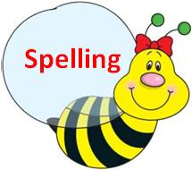  - Form verbs with prefixes, for example, dis, de, mis, over and re  - Use prefixes and suffixes, understanding how they affect root words, for example, convert nouns or adjectives into verbs by adding a suffix such as, ate, ise, ify  - Distinguish between homophones and other words which are often confused their, there, they’re, to, two, too  - Spell words with silent letters such as, knight, psalm, solemn  - Continue to distinguish between homophones and other words which are often confused  - Spell identified misspelt words from the Year 5 and 6 word list  - Understand that the spelling of some words needs to be learnt specifically as they do not follow the rules  - Use the first 3 or 4 letters of a word to check its spelling and meaning in a dictionary  - Use a thesaurus  - Use a range of spelling strategies  Handwriting  - Write legibly, fluently and with increasing speed  - Choose which shape of a letter to use when given choices and deciding whether or not to join specific letters  - Choose the writing implement that is best suited for the task  - Presentation of work should be consistently of a high standard | Vocabulary, grammar and punctuation  - Recognise vocabulary and structures that are appropriate for formal speech and writing  - Experiment with beginning sentences in a variety of ways, using adverbials, conjunctions, ing, ed  - Use grammatical features and vocabulary appropriate for the text types taught so far  - Choose rich vocabulary to engage the reader and have an impact  - Use the perfect forms of verbs to mark relationships of time and cause  - Add well chosen detail to interest the reader through expanded noun phrases  - Use cohesive devices (connecting adverbs and adverbials) to link ideas within paragraphs  - Use brackets, dashes or commas to show parenthesis  - Use modal verbs or adverbs to indicate degrees of possibility  - Use relative clauses beginning with who, which, were, where, when, whose, that or with an implied (i.e. omitted) relative pronoun  - Use commas to clarify meaning or avoid mixed meanings  - Use a colon to introduce a list  - Punctuate bullet points consistently

